

Mechanical Group Progress Report

A Report Made By Alex, Rosani and Sean

Contents

Introduction 3

Alex’s Contribution to the Mechanical Team 4

NSK Ball Screws, What are They? 4

# Introduction

Our primary goal for the Semester 1 was to automate a ***Colchester Student 1800 Lathe*** that was originally completely mechanical. To complete this we decided that it was best to separate into three different groups and work on individual components rather than working on different things all together. Our groups consisted of Mechanical, Electrical and Control, they all have their own goals and objectives that needed to be completed. Being In the Mechanical Group we were tasked with: Identifying the Ball Screws of the X and Y axis, Identifying the Lathe Components

# Alex’s Contribution to the Mechanical Team

My Contribution to the Mechanical Team consisted of:

* NSK Balls Screws What are they?
* View of the Lathe.
* Specifications of the Lathe.
* Tool Post Carriage CAD Drawing
* Tool Post Holders CAD Drawing

## NSK Ball Screws, What are they?

I’ve done some small research / information on how ball screws are and how they work. Their Function and their design.

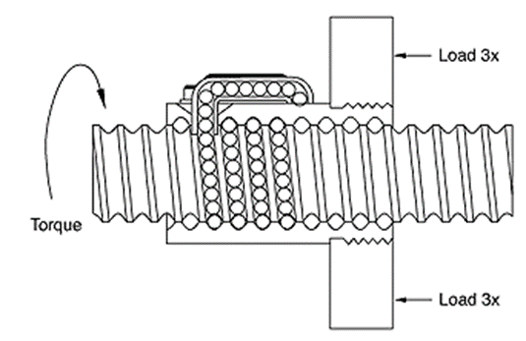

I’ve also included some of the equations that can be used to calculate the following:

$$T=\frac{Fl}{2πv}$$

T= Torque applied to Screw or Nut

F= Linear Force Applied

l= Ball Screw Lead

v= Ball Screw Efficiency

# Conclusion

In conclusion we have worked quite effectively during the 8 weeks that have elapsed. We were able to achieve quite a lot given that we